School Library

In this project you will make a school librarian character that can make reading book recommendations.

If you describe a book to it, it will try to predict who that book might be suitable for.

You will teach the computer to recognise fiction books of different reading levels by giving it examples of each.

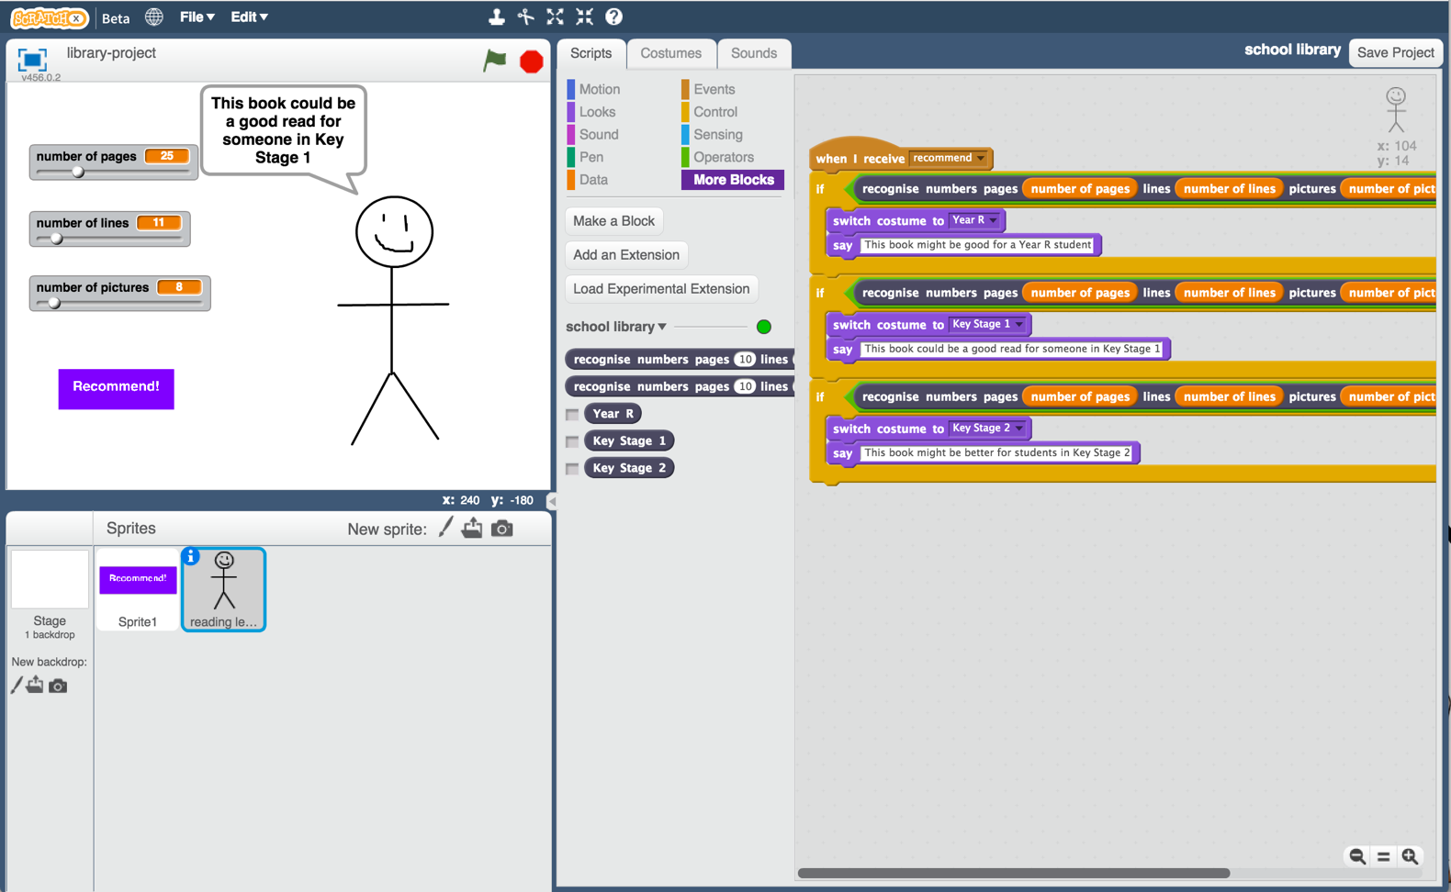

This project worksheet is licensed under a Creative Commons Attribution Non-Commercial Share-Alike License

http://creativecommons.org/licenses/by-nc-sa/4.0/

1. You need a collection of fiction books for this project.   
   Go to the school library!
2. Find examples of fiction books of different reading levels, and collect the following information about them:  
   * Number of pages in the book  
   * Number of lines in each page (*choose a typical full page of text*)  
   * Number of pictures in the book (*if the book is too long, or there are too many pictures to count, it’s okay to make an estimate*)  
   * The reading level (e.g. Year R / Key Stage 1 / Key Stage 2.   
   *Your school may have different ways to group fiction books, such as by reading level or using coloured bands. Try to limit yourself to just a few different reading levels though*)
3. Do this for at least five books at each reading level.   
   *More books would be better if you can find them and have the time!  
   It’s easiest to collect this on pen and paper. Try drawing out a table to make it easier.   
   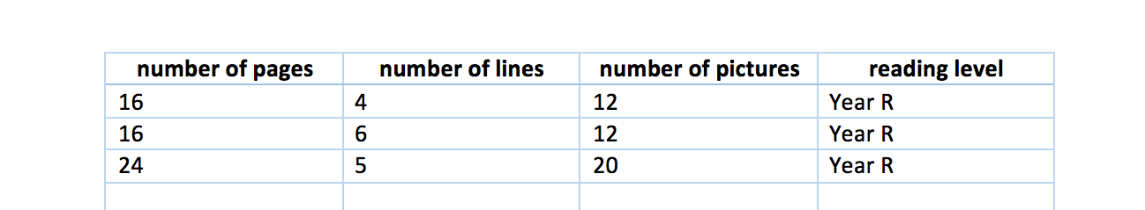*
4. Go to <https://machinelearningforkids.co.uk/> in a web browser
5. Click on “**Get started**”
6. Click on “**Log In**” and type in your username and password  
   *If you don’t have a username, ask your teacher or group leader to create one for you.  
   If you can’t remember your username or password, ask your teacher or group leader to reset it for you.*
7. Click on “**Projects**” on the top menu bar
8. Click the **“+ Add a new project**” button.
9. Name your project “school library” and set it to learn how to recognise “**numbers**”  
   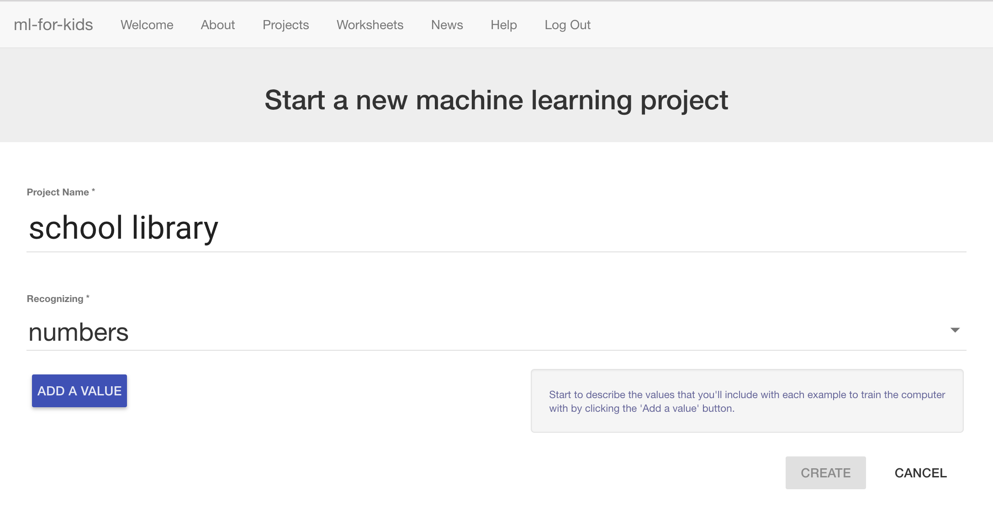
10. Click “**Add a value**” three times.   
    Set the type of all these values to “number”.   
    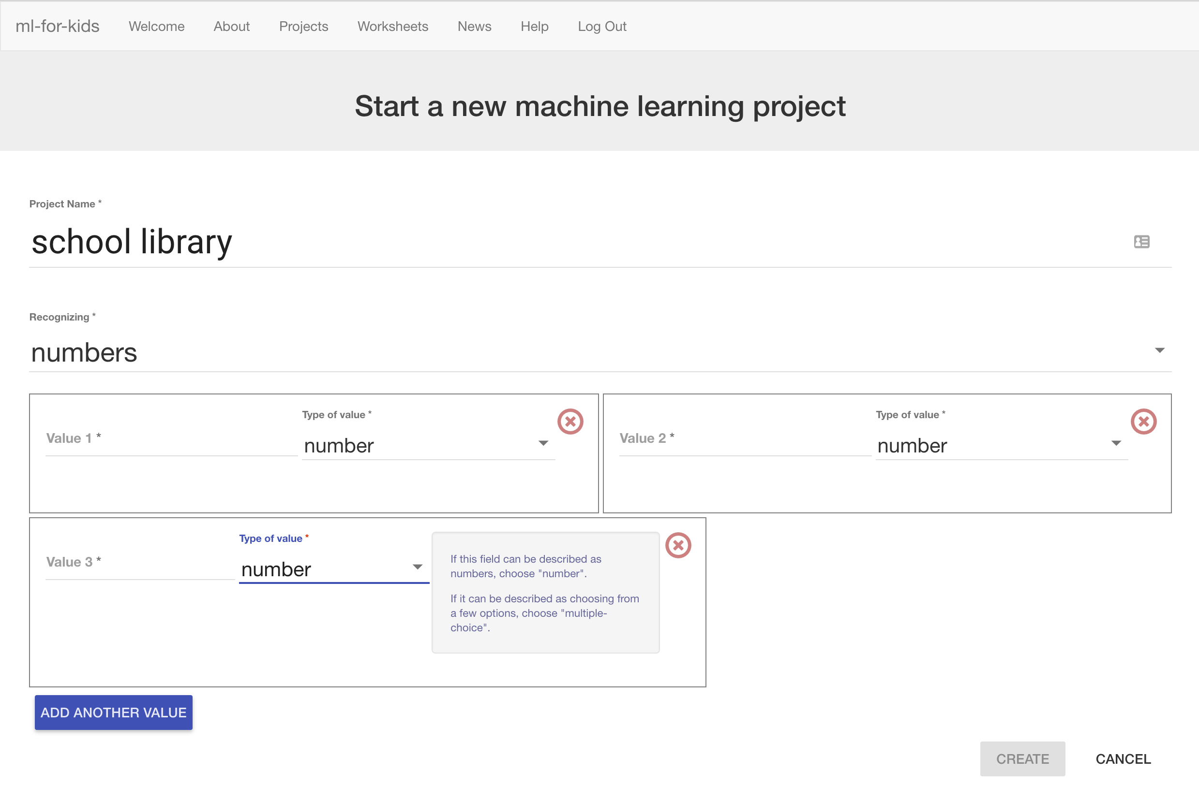
11. Name the three fields “pages”, “lines” and “pictures”  
    *We will use these for:  
    pages – the number of pages in a book  
    lines – the number of lines on a page  
    pictures – the number of pictures in the book*  
    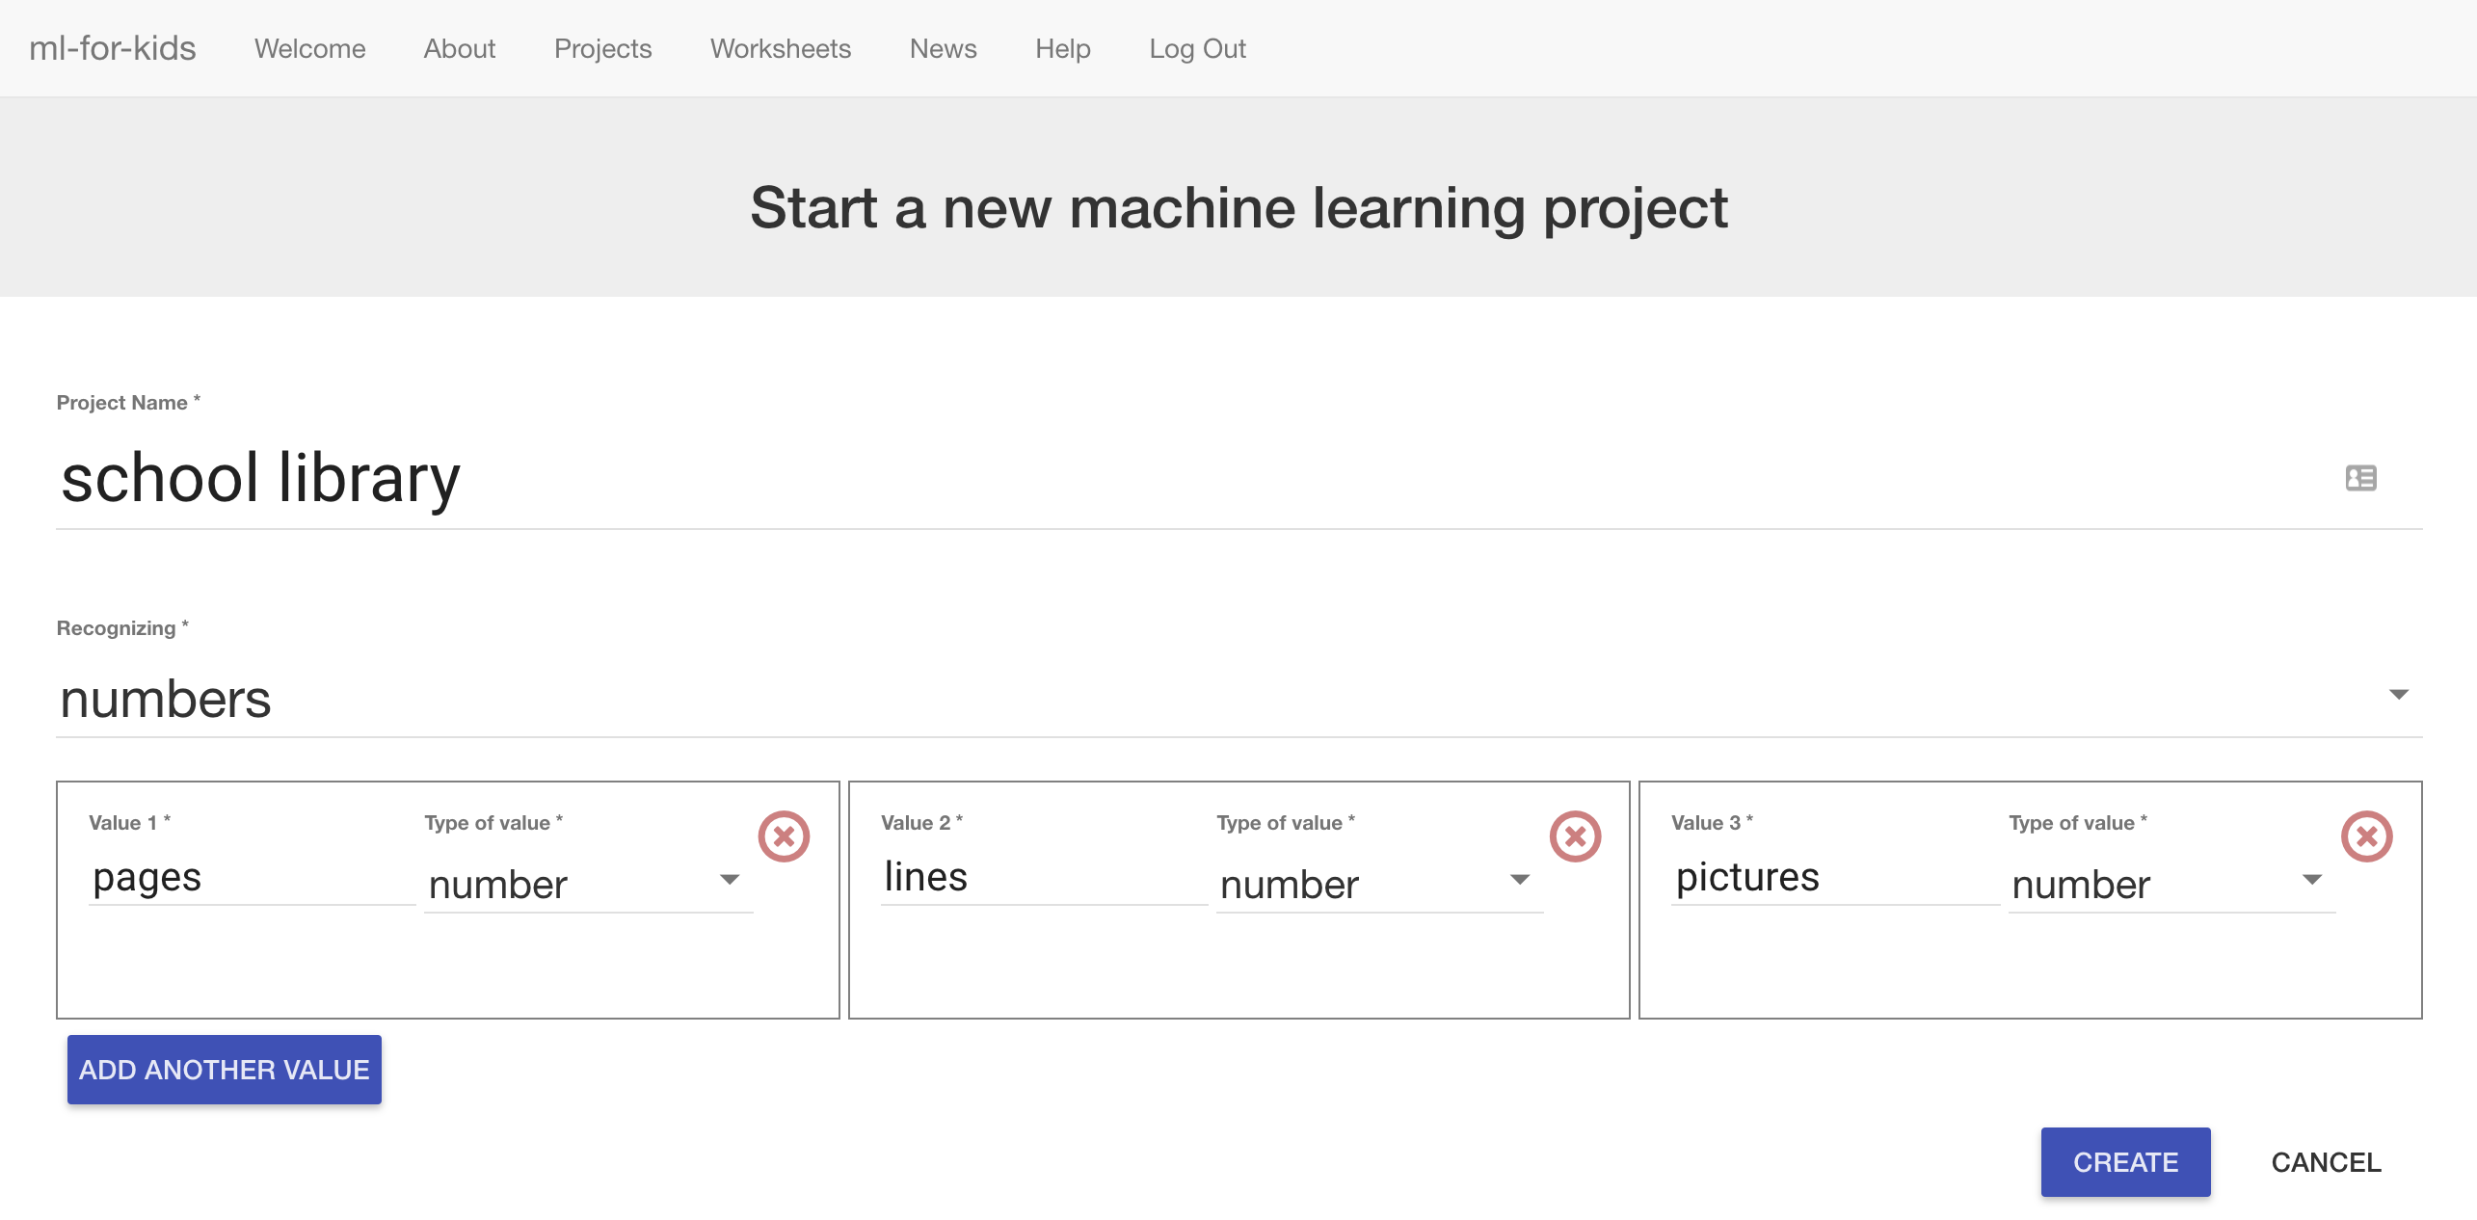

1. Click “**Create**”  
   “school library” should now be in your projects list. Click on it.   
   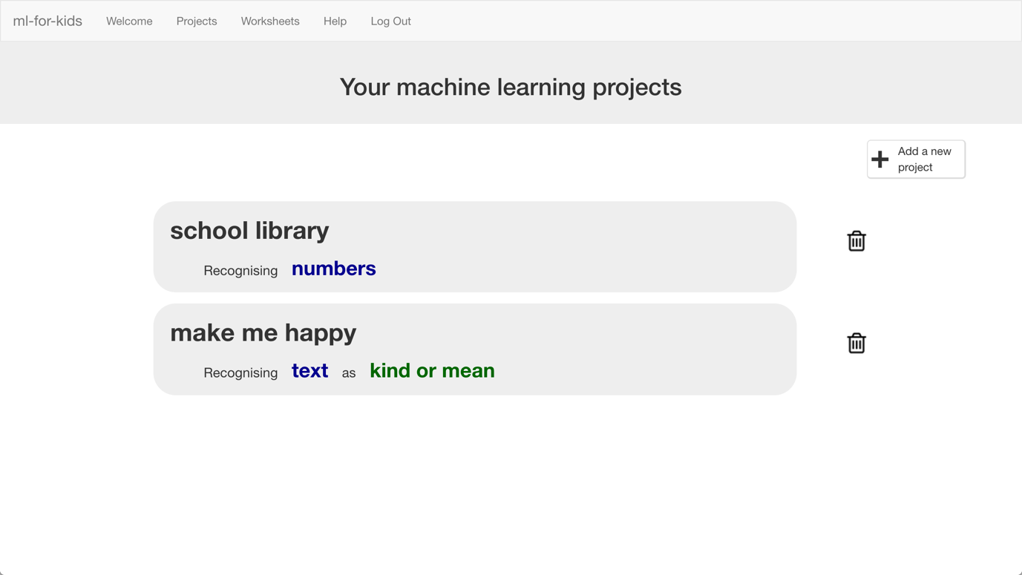
2. We’ll start by collecting examples of books to train the computer with. Click the **Train** button.  
   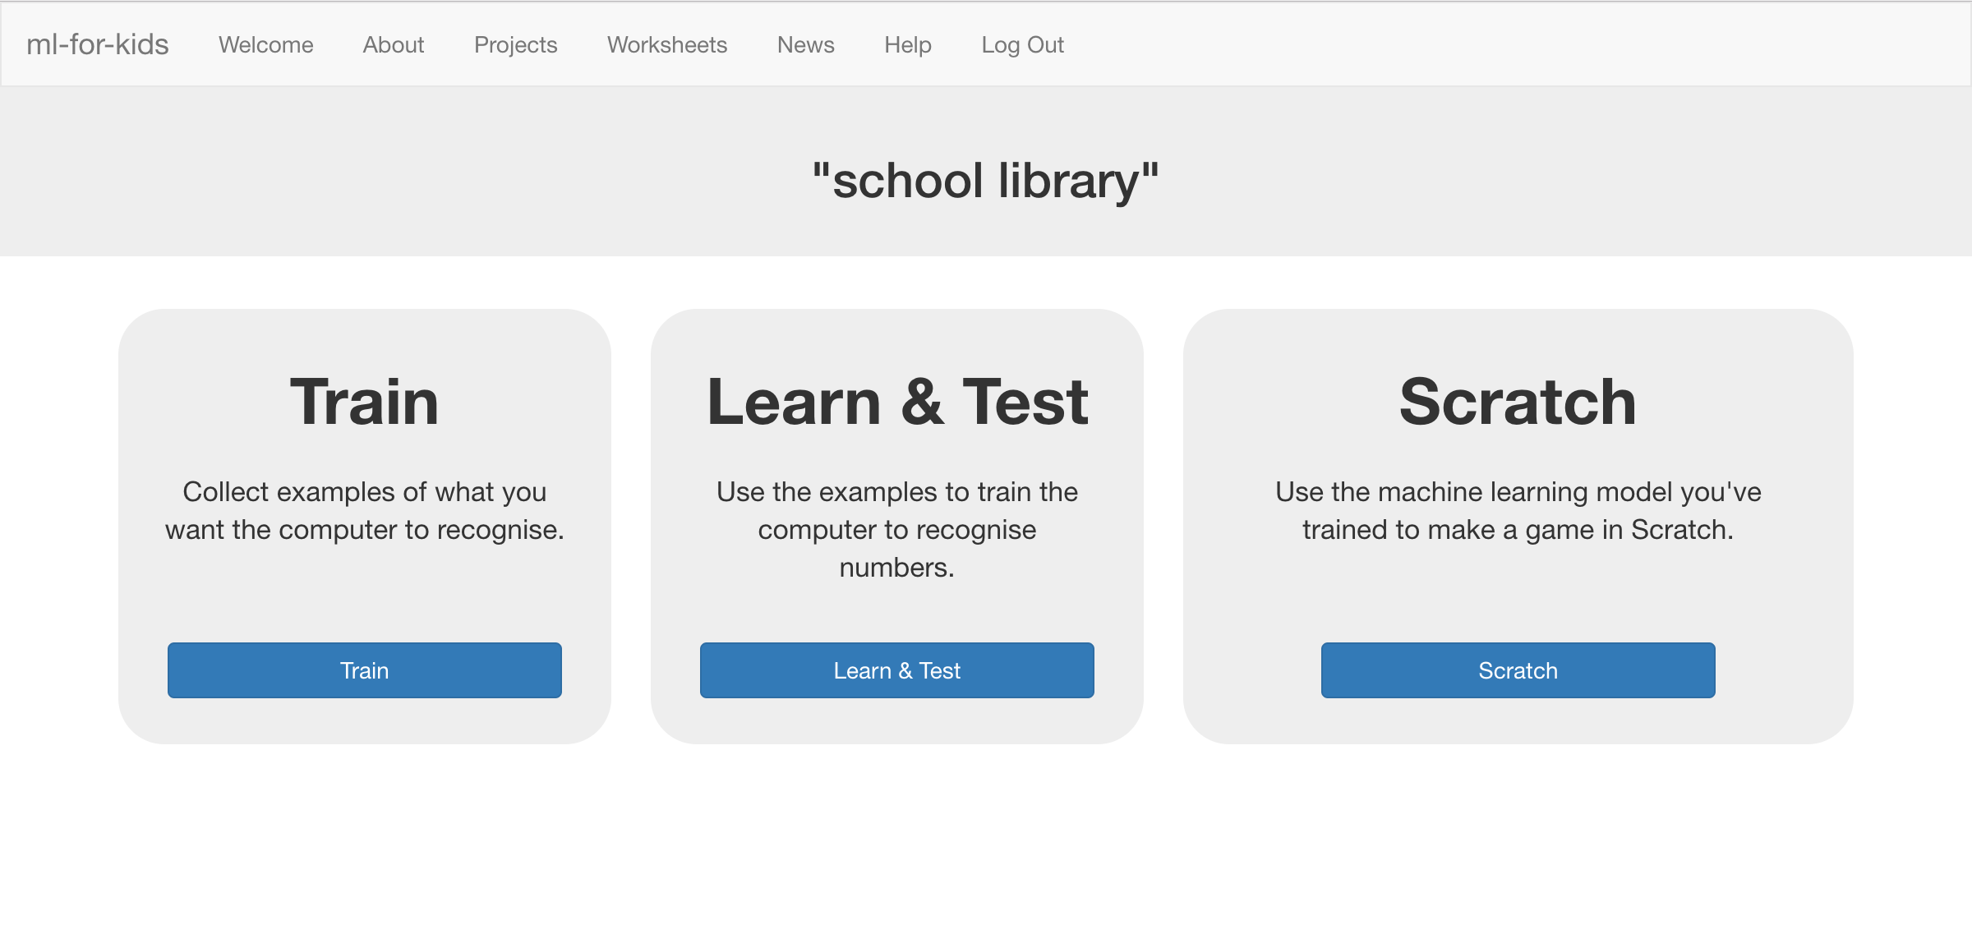

1. Click on **“+ Add new label**” and call it “Year R”.   
   Do that again, and create a second bucket called “Key Stage 1”.  
   Do that again, and create a third bucket called “Key Stage 2”.  
   *If you used different names for reading levels, use those instead.*   
   
2. Click the “**Add example**” button in the “Year R” bucket, and type in the values from your first Year R book. Click “**Add**”  
   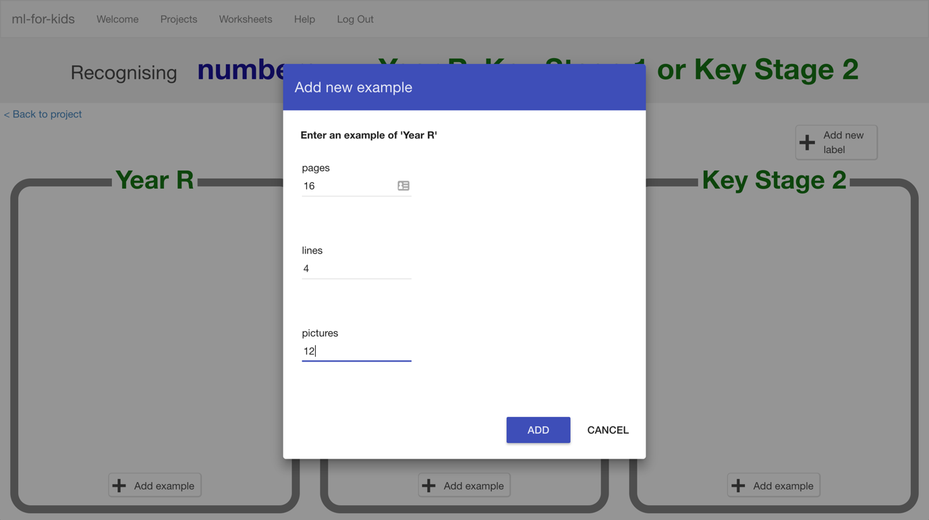

1. Do this for the values of all the books you collected.  
   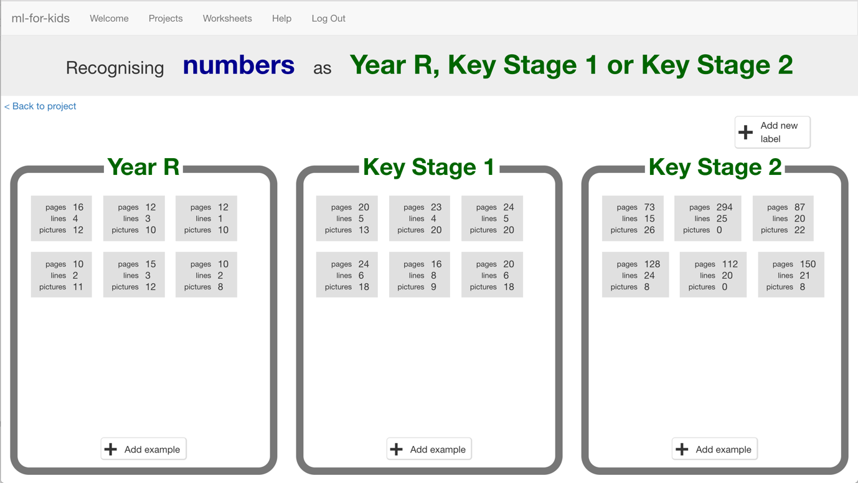

1. Click the **“< Back to project**” link once you’ve finished to go back to the Project menu, then click on the “**Learn & Test**” button.
2. Click the “**Train new machine learning model**” button at the bottom of the page.   
   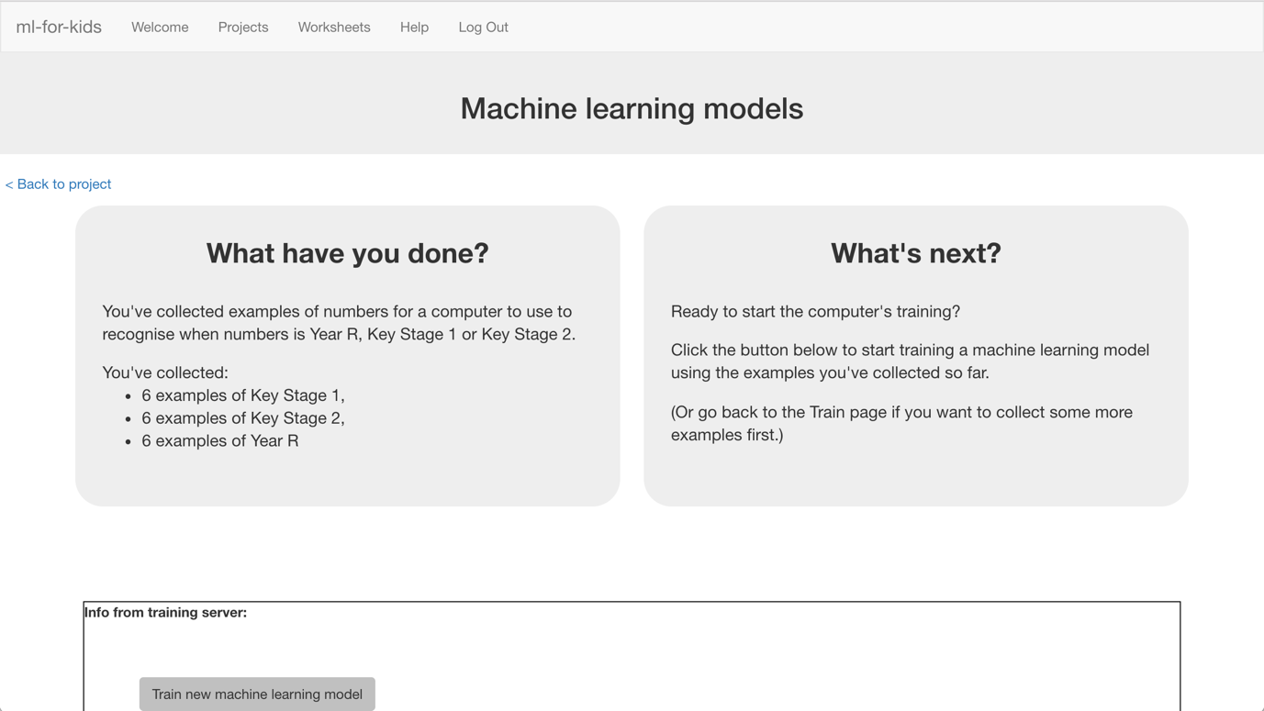
3. Use the Test form to try out the model you’ve trained.   
   *Test it with a book that you haven’t shown the computer before. In other words, not one that you’ve used in your examples in Training.  
   If you’re not happy with how the computer predicts the reading level, go back to step 15, and add some more examples.   
   Make sure you repeat step 18 to train with the new examples though!*  
   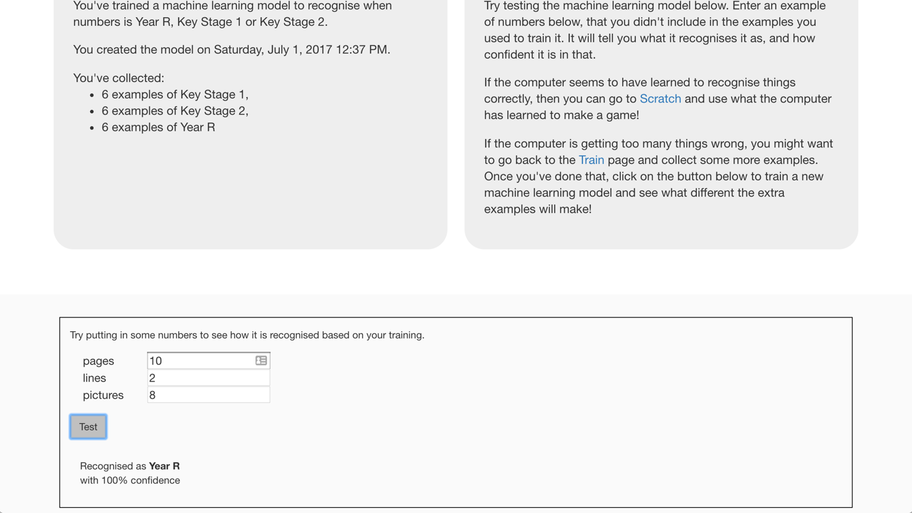

**What have we done so far?**

You’ve started to train a computer to predict the reading level for a fiction book. You’ve done this by training it recognise sets of numbers as being “Year R”, “Key Stage 1”, or “Key Stage 2”.

These examples are being used to train a machine learning “model”.

This is called “supervised learning” because of the way you are supervising the computer’s training.

The computer will learn from patterns in the examples you’ve given it. These will be used to be able to make predictions for numbers about new books.

1. Click the **“< Back to project**” link, then click the “**Scratch**” button.   
   *This page has instructions on how to use the new blocks in Scratch from your project. Keep the page open if you need to check on how to use them.*

**Tips**

**More examples!**

The more examples you give it, the better the computer should get at recognising the reading level for books.

**Try and be even**

Try and come up with roughly the same number of examples for each reading level.

If you have a lot of examples for one reading level, and not the others, the computer might learn that reading level is more common and more likely, so you’ll affect the predictions that it makes.

**Mix things up with your examples**

Try to come up with lots of different types of examples.

For example, don’t choose lots of examples of very similar books in a set or series.

1. Click the “**Open in Scratch**” button at the bottom to launch the Scratch editor.   
   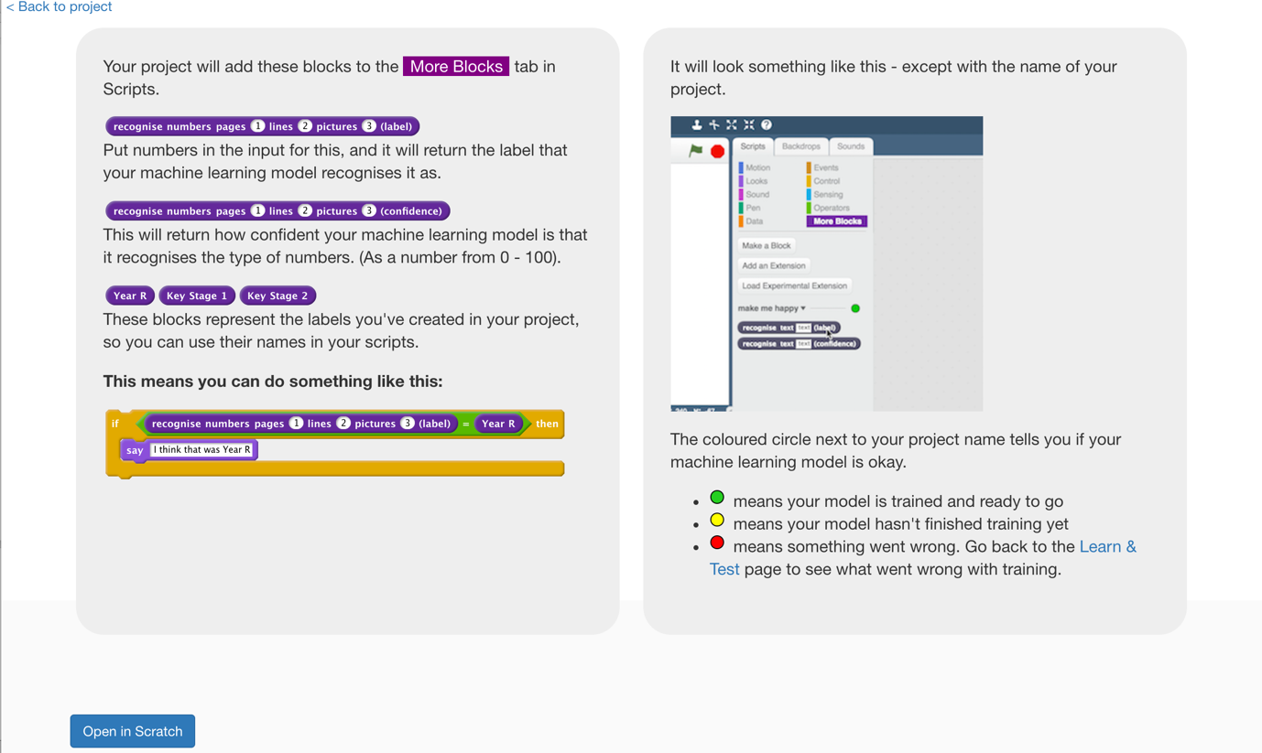
2. You should see new blocks in the “More blocks” section from your “school library” project.  
   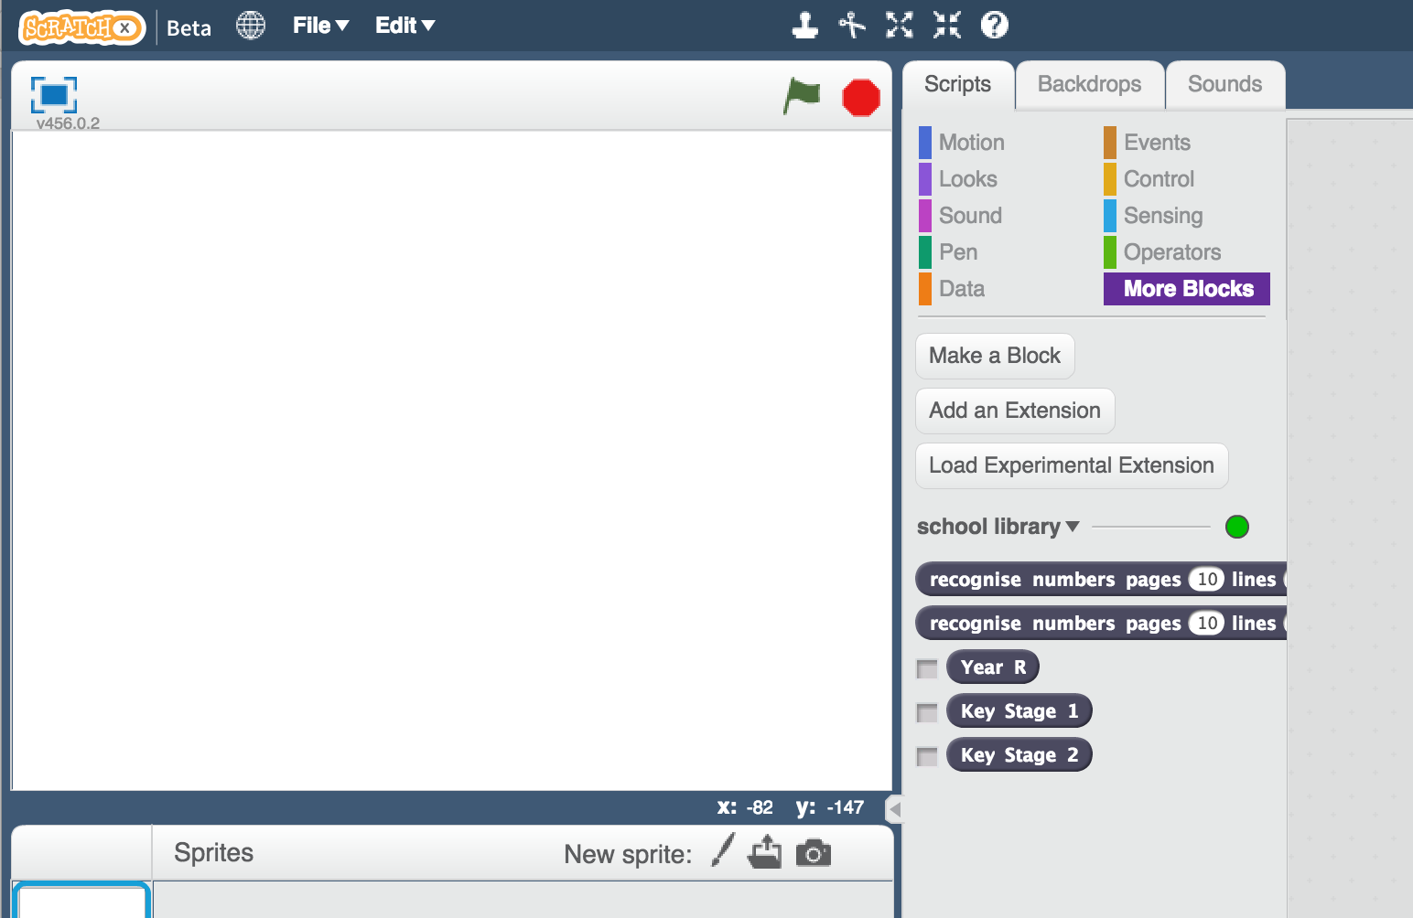
3. Create three new variables, for all sprites. Call these “number of lines”, “number of pages”, and “number of pictures”.  
   *Leave them ticked, so they stay visible on the stage.*  
   
4. Set all of the variables so that they are displayed on the stage as “sliders”. Spread them out a bit so you have space.  
   *Right click on the variables on the stage, and choose “slider”.   
   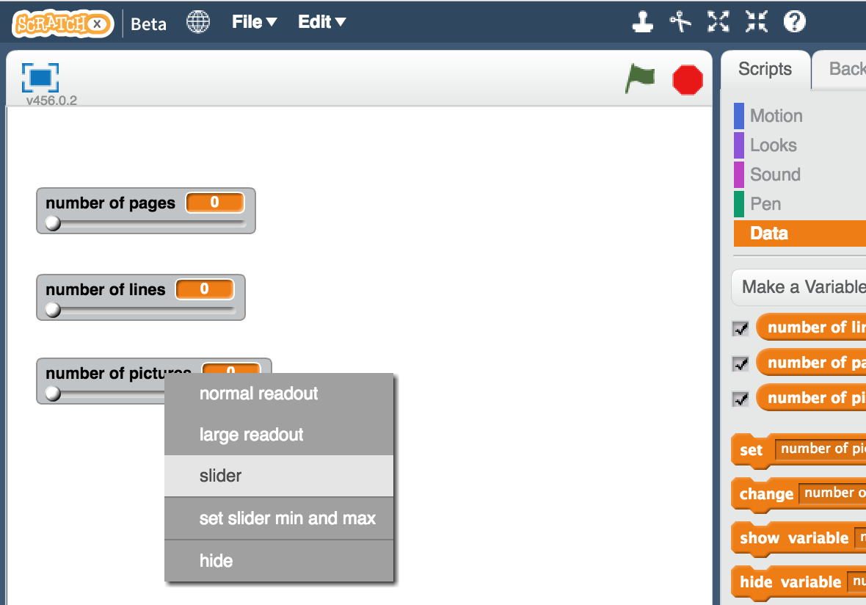*
5. Update the minimum and maximum for each of the sliders so that the range is more sensible.   
   *For example, you could use minimum of 0 and maximum of 300 for pages.   
   You could use 0 – 40 for number of lines.  
   You could use 0 – 50 for pictures.   
   But choose what you think makes sense based on your books.*  
   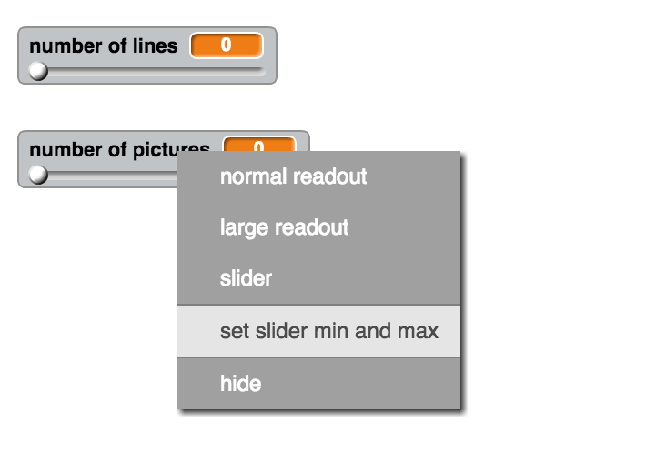
6. Create a new sprite by clicking on the paint brush button next to the “New sprite” label.   
   
7. Draw a button and give it a label like “Recommend”.   
   *Move it to under your three sliders, and adjust the size so that it fits.*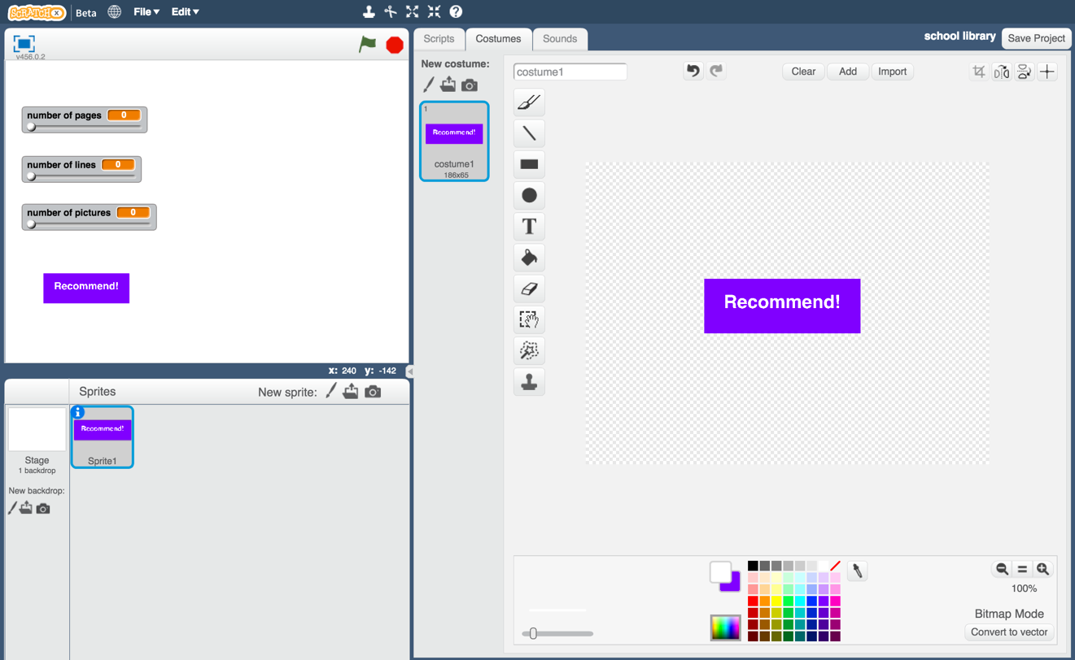
8. Click on the Scripts tab.
9. Create a script for this button sprite, so that clicking the button broadcasts a new “recommend” message.  
   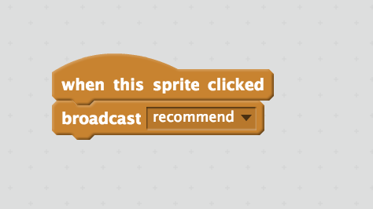
10. Click on the “Paint new sprite” paintbrush icon again, to create another sprite.
11. Name the sprite “reading level”  
    *Click on the blue* ***i*** *icon shown below to name the sprite*  
    
12. Create three costumes for the reading level sprite.  
    *Click on the paint brush button next to the “New costume” label to do this.*   
    
13. Name the costumes “Year R”, “Key Stage 1”, and “Key Stage 2”  
    *Type the names into the white box shown below*  
    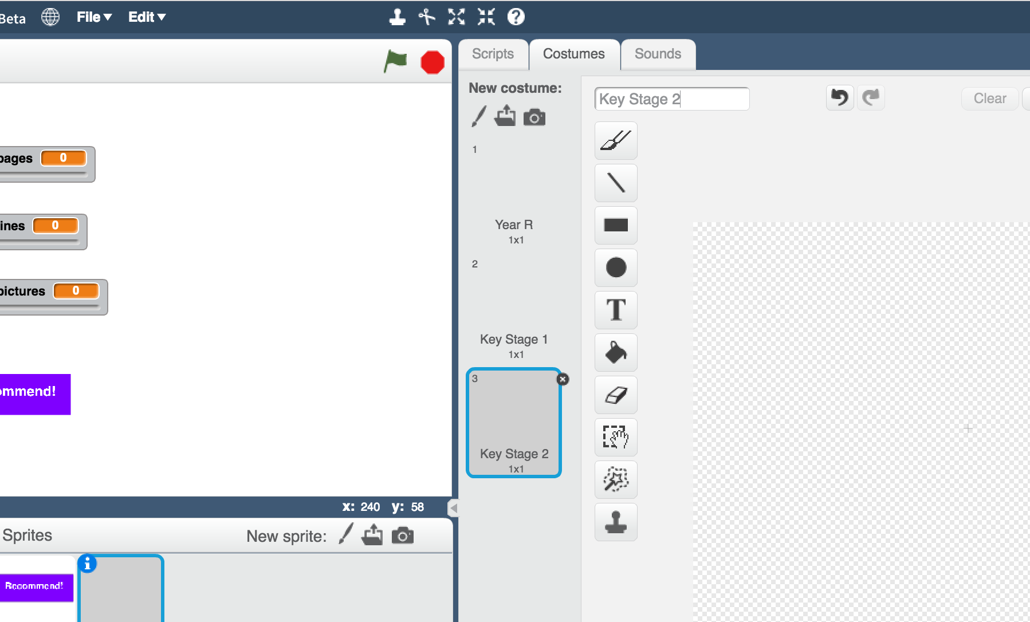
14. Draw a child in each costume.   
    *Draw a small child in the Year R costume  
    Draw a medium child in the Key Stage 1 costume  
    Draw a larger child in the Key Stage 2 costume  
    If you’re not good at drawing, a stick figure is fine!  
    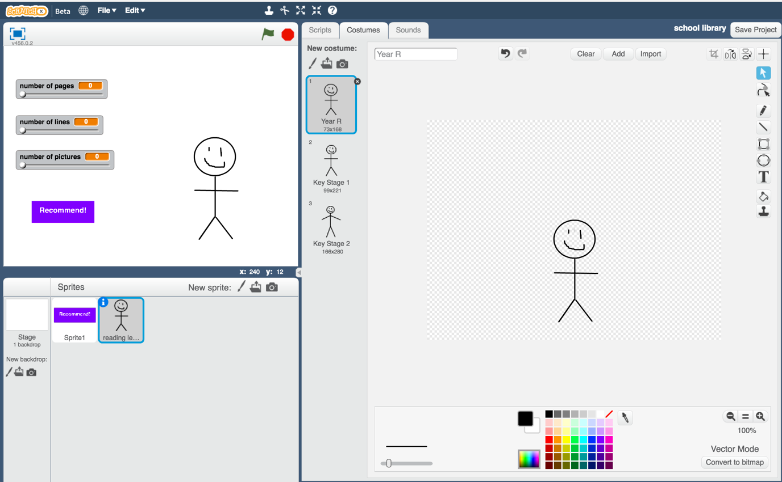*
15. Click on the Scripts tab and enter the following script.  
    *Think about how you could use “Duplicate” to make this easier.*  
    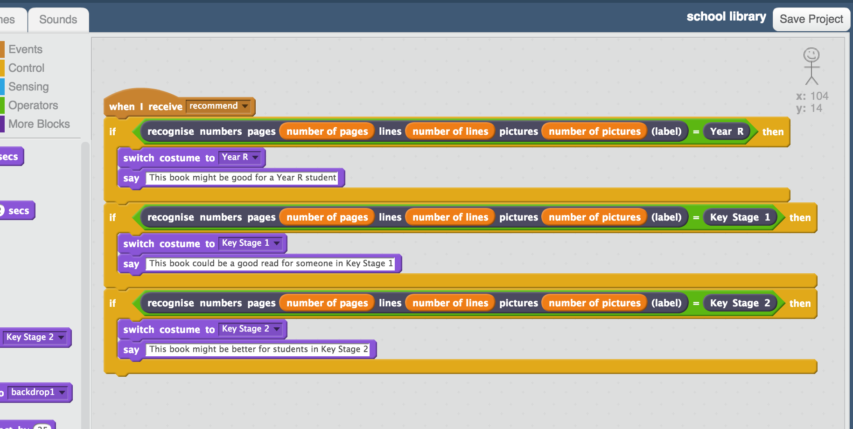
16. Test your project!  
    *Set the sliders to values from a new book – a book that you didn’t use to train your machine learning model.   
    Click the recommend button to see a recommendation for who the book is suitable for.*  
    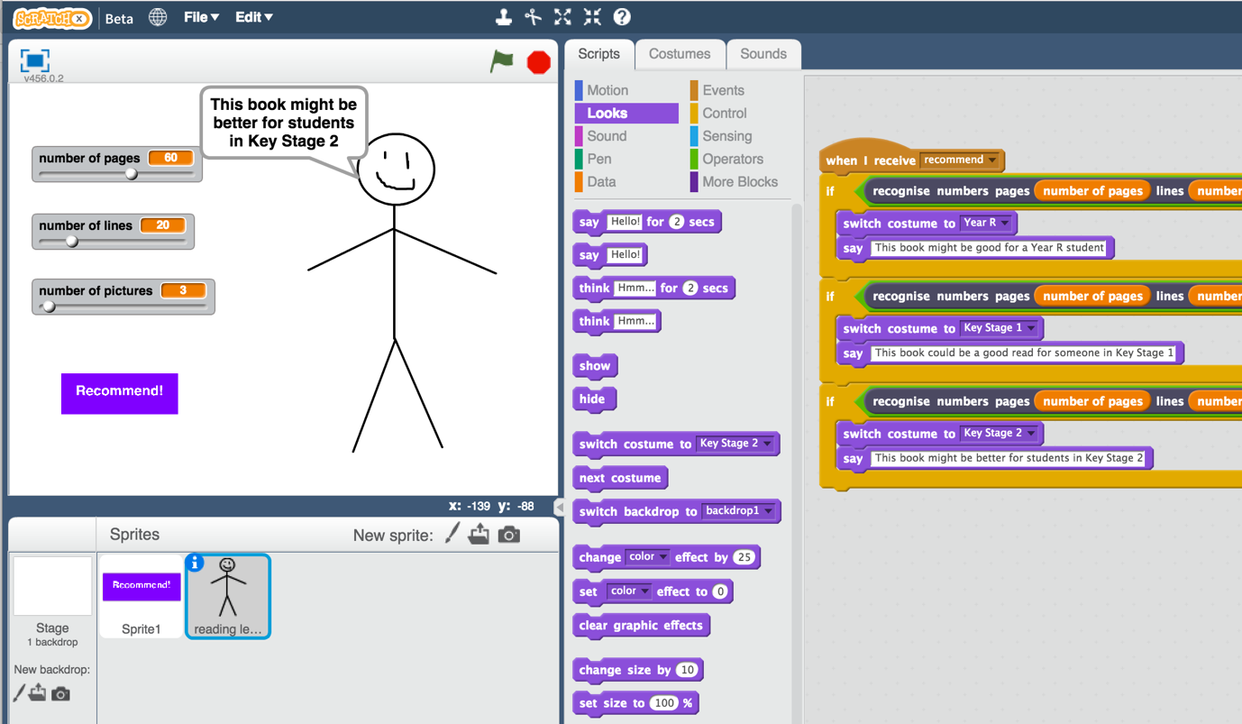
17. Save your project  
    *Click File -> Save Project*

**What have we done so far?**

You’ve created a Scratch game with a school librarian that uses machine learning.

Your character is using “predictive modelling” – making a prediction of who a book might be suitable for, based on the machine learning model that you’ve made.

You trained that machine learning model by collecting examples of books, and telling the computer what reading level each of them would be. The more examples you give it, the better it should get at recommending correctly.

**Ideas and Extensions**

Now that you’ve finished, why not give one of these ideas a try?

Or come up with one of your own?

**Choose different numbers**

Instead of number of pages, number of lines, and number of pictures, what other numbers could you use?

What other numbers or measurements could you make that you think could be used to make predictions or recommendations?

The height of the book? The thickness? The size of the letters?

Try creating a new numbers project and this time use your own ideas. Compare it with your first project – is it better or worse at making recommendations?